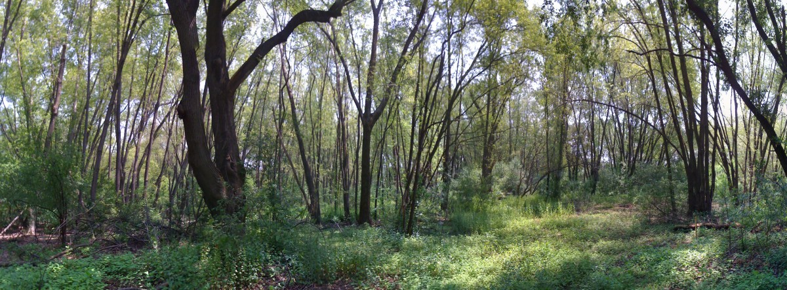
The Silver Maple Forest:
The Impact of Development on Our Floodplain

Hearing of the Cambridge Committee on Health and the Environment
Councilor Leland Chung, Chair
Tuesday 10/28, 3:00 – 5:00 pm
Presenters:
Charles Katuska, Environmental consultant and
Professional Wetland Scientist. Charles has over 25 years experience in the identification, delineation, mapping, impact assessment and regulatory review of Massachusetts wetland resource areas. He is employed as professional staff for Conservation Commissions in the Towns of Braintree and Weymouth and served 16 years as a Conservation Commissioner between the Towns of Carver and Southborough. He has provided training to more than 1000 Massachusetts Conservation Commission members with Program, “The Basics of The MA Wetlands Protection Act”.
Bruce L. Jacobs, President of HydroAnalysis Inc. Bruce has more than 20 years of experience as an environmental engineer, working on a wide variety of problems in water resources, groundwater hydrology and contaminant transport, storm water management, and surface water quality. He specializes in computer modeling and data analysis. Bruce particularly enjoys creating environmental software and is the author of several computer codes, including the EnviroInsite groundwater data visualization software

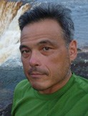
David Morimoto, Director of the Natural Sciences and Mathematics division at Lesley University. David has 24 years of experience as an ecologist and over sever years of experience working with college and high school students in the Alewife area. His current work focuses on mapping urban bird diversity in Cambridge. He is an experienced naturalist and ornithologist, with expertise in New England ecosystem functioning and urban/suburban ecology. Dr. Morimoto and his upper level science students have recently completed a field study on the composition and estimated ecosystem services of the Silver Maple Forest.

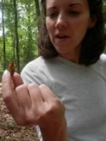
Amy Mertl, Assistant Professor of Biology at Lesley University. Amy specializes in community ecology and animal behavior. She investigates the evolution of division of labor and interspecific competition, as well as how faunal communities respond to ecological disturbance gradients. Her current research involves investigating the diversity, ecology, and structure of ant and termite communities in urban and suburban New England forests. She has worked with Lesley students on field-based ecology at the Alewife reservation for four years, as well as participated as a mentor in the FAR Ecology camp. She has researched the economic value of the ecosystem services provided by urban forests and the Silver Maple Forest in particular.

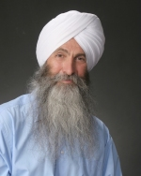
EkOngKar Singh Khalsa, Mystic River Watershed Association Executive Director. EK has thirty years professional experience in environmental protection and restoration, urban planning, low impact and Brownfields development and broad understanding of public policy connected to these fields. His background includes extensive training in environmental science and due diligence including: wetlands delineation and regulation, stormwater management system design and installation, soil and groundwater preservation and restoration as well as hazardous waste investigation, management and remediation. He has broad experience and background in landscape design, zoning and land use regulations and direct experience with commercial site planning and development, residential subdivision design, and professional land surveying and engineering.

With thanks to:
Councilor Leland Cheung
Special thanks to Rozann Kraus
Friends of the Alewife Reservation
Green Cambridge
Mystic River Watershed Association

