A Solstice Ritual of Death and Life
Call to Action
Conserve and Restore the Forest Land

Feel, mourn and celebrate our nature kinship
Rev. Lilia Cuervo and Arts Diva Maya Apfelbaum Lead Annual Ritual
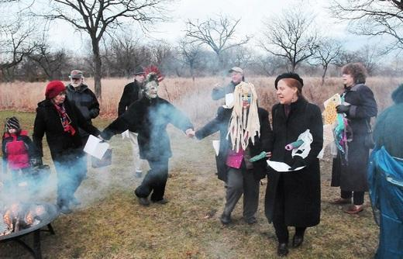
December 20th at 2 pm-
Alewife Reservation Parking Lot, Acorn Park Drive
From the T, over Little River Bridge to sign and turn west until end
DAVE BROWN LEADS WILDLIFE WALK AT 3-5 TO HELP US FACE WHAT WE MUST

Dance around the Fire to Pay Homage to Our Departed Trees Return Light and Hope to our Mystic/Alewife communities
Call 617-415-1884 for more information or weather alert
Sponsored by Friends of Alewife Reservation www.friendsofalewifereservation.org,

Bring your nature spirits, instruments, a favorite reading and your tears.

