The Belmont Uplands Site
and Alewife Reservation:
An Ecological Overview of
Present and Future Status
Prepared for
FRIENDS OF ALEWIFE RESERVATION
186 Alewife Brook Parkway, Suite 304
Cambridge, Massachusetts 02138

Prepared by
NORMANDEAU ASSOCIATES, INC.
25 Nashua Road
Bedford, NH 03110

R-20694.000

February 2006
Table of Contents

Page

1.0 Introduction......................................................................................................... 1
2.0 Principal Findings............................................................................................... 1
2.1 Attributes of Belmont Uplands and Alewife Reservation....... 1
2.2 The Belmont Uplands as Human Habitat........................................... 2
2.3 The Belmont Uplands Development Proposal................................ 3
3.0 Summary................................................................................................................... 7
4.0 References Cited and Reviewed (incomplete as of 7 Feb. 2006). 10

List of Figures

Page

Figure 1........ Size, spacing, orientation and shape of habitat fragments relative to probability of species survival. After Faaborg et al. (1995) after Diamond (1975)............................................................... 5
Figure 2........ Proposed development area (arrow), Belmont Uplands site. Approximate boundary from Epsilon Associates, Inc. (14 Oct. 2003), Conceptual Conservation Restriction Plan. Base Map: 2001 Massachusetts GIS Orthophotos............................................................................... 6
Figure 3........ Core area (shaded) for interior-habitat species at Alewife Reservation without Belmont Uplands development (top) and with development (bottom). Setback from unvegetated edge ~ 100 m 8
Figure 4........ Recommended terrestrial management area around a vernal pool. Illustration from Calhoun and Klemens (2002)....................................................................................................... 9
Figure 5........ Relationship to the proposed Belmont Uplands development of two reported vernal pools and their respective 750-foot-diameter terrestrial management areas. Darkened circles indicate approximate area of State jurisdictional protective buffer zone to be observed around vernal pools

1.0 Introduction
This report comes at the request of residents of Belmont and Cambridge for study and reference by the Belmont Conservation Commission and other groups such as the Friends of the Alewife Reservation (FAR), to provide a summary review of findings to date and an analysis of ecological impacts to be anticipated from proposed development of the O’Neill Properties tract commonly known as the Belmont Uplands. This report expands on ecological principles and opinions previously expressed in a letter to the City of Cambridge (Fairbairn 2003), and pays specific attention to the current development proposal for a high-density residential development on the Belmont Uplands (AP Cambridge Partners II 2005).

2.0 Principal Findings

2.1 Attributes of Belmont Uplands and Alewife Reservation
Amenity. As a preface to the following site-specific discussion, it should be noted that properly managed open space provides perceived benefits (e.g. beauty, tranquility, room to exercise, microclimate control, biodiversity) that taken together can be assigned a rough monetary value. For example, the National Park Service (1995) has documented the economic value to real estate adjoining open space. In a study of four parks in Worcester, Massachusetts, a house 20 feet from a park sold for an average $2,675 (1982 dollars) more than a similar house 2,000 feet away. In Amherst and Concord, Massachusetts, cluster-zone housing set in permanently protected open space appreciated at a higher rate than houses in conventional subdivisions. Proximity to an arboretum in Dayton, Ohio accounted for an estimated 5% of average selling price. In Columbus, Ohio, proximity to a park and river accounted for 7.35% of the selling price. The perceived value of the open space appeared to be positively correlated with natural landscape rather than highly developed facilities; with low-intensity recreation and limited vehicular access, and effective maintenance and security. After a neighborhood in Boulder, Colorado bought a greenbelt, adjoining property values rose so high that the extra tax that could have been collected, based on improved market value, would have paid for the purchase in three years. These sound like arguments for cultivating the open-space amenity rather than diminishing it.
Uniqueness As the major upland component of an unmanaged stand of forested upland and wetland, the Belmont Uplands represent an important part of a minute open-space type in Greater Boston (Katuska 2003). The entire Alewife Reservation shows on the Biomap of the Boston Basin Ecoregion as a fine sliver of green threading the matrix of developed land surrounding it (NHESP 2001). The Belmont Uplands portion of this rare forest enhances the uniqueness by virtue of stand species composition, which consists of monotypic Silver Maple (Acer saccharinum), an unusual species to occur so densely outside its typical annual floodplain habitat. Vigorous regeneration of young Silver Maple indicates the likelihood of its persistence as a stand dominant for at least another century.
Stormwater detention and retention. Among the social benefits this forest provides (Katuska 2003, 2004), the control of stormwater runoff ranks high because of the surrounding area’s vulnerability to flooding and sewerage overload (Mystic River Watershed Association 2002).
Water pollution amelioration. Another of the free public benefits provided by the forest and associated plant communities, this function, which promotes biochemical as well as physical interactions, follows naturally from the physical effects of detention and retention described by Katuska (2003).
Dispersal and migration support. By way of the Little River and its flanking riparian zone, many aquatic and terrestrial animals come and go in the Reservation. To some, it may be an annual endpoint (e.g. the shad and herring) or way-station (e.g. migratory birds), to others an occasional refuge (e.g. deer,). The connectivity of Little River with Alewife Brook downstream facilitates access to the Reservation by mammals that would otherwise be absent from this densely populated human environment (e.g. River Otter, Mink, Beaver).
Representativeness. Although protected rarities occur (e.g. wintering Bald Eagle at Little Pond), the Reservation’s chief value to plant and animal life lies in the support it provides to a wide variety of relatively common species. Many of these have been well studied, notably mammals and birds (Sanders 1994, FAR 2004, and others). An area of little over 100 acres that has breeding records for over 45 bird species and reports of nearly 20 mammals owes much to its diversity of plant communities, not the least of which is the upland forest. Ten of the breeding bird species require nest cavities, which form more readily in Silver Maple than in many other trees (Katuska 2003).

2.2 The Belmont Uplands as Human Habitat
Whether an area’s desired use is wilderness or shopping mall, it serves the interest of our own species’ complex wants and needs. As part of an ever-dwindling urban open space, the Belmont Uplands tract has become increasingly the object of intense intraspecific (human) competition. A 14-year review by the National Park Service ranked residential or commercial development as the most common type of negative human influence on National Natural Landmarks, many of which are small biotic preserves (Shafer 1995) similar in scale to the Alewife Reservation. Recent statements of interest in the Reservation and its open-space environs include the following efforts, listed by primary purpose.

Recreational Development:
○ Blair Pond Master Plan (MDC 1999)
○ Alewife Reservation and Alewife Brook Master Plan (MDC 2003)

Preservation and Education:
○ Friends of Alewife Reservation activities and publications

Restoration:
○ The 10-acre Muskrat Marsh project currently under study by the Massachusetts Wetlands Restoration Program
○ The Combined Sewer Overflow (CSO) Separation project proposed by the Massachusetts Water Resources Authority and City of Cambridge for 3.5 acres south of Little River, aimed at effecting an 85% improvement in water quality and restoration of some 10 wetland acres.

Commercial and Residential Development:
○ Acorn Park office expansion (Discovery Park) on previously filled land
○ The current proposal to build housing on about 8 acres of the Belmont Uplands forest (AP Cambridge Partners II 2005).
Both these projects include an open-space habitat restoration and enhancement component. Both differ from all the foregoing projects described by incurring a net loss of open space and privatization of the developed land use. The foregoing public-interest projects generally complement and enhance one another.

2.3 The Belmont Uplands Development Proposal
The applicant’s original proposal for a business workplace includes environmental data and plans (Epsilon Associates, Inc. 2003) that are generally relevant to the applicant’s superseding alternate proposal for a housing complex (AP Cambridge Partners II 2005). Throughout the material reviewed, the applicant demonstrates due observance of the regulations: provisions to contain and treat stormwater runoff on-site to the required standards, and to accommodate the required volume of flood water; limitation of direct impacts on wetland within permissible thresholds; due note of the absence of impacts on rare, threatened and endangered species; avoidance of known vernal pools and their buffer zones; mitigation of direct wetland impacts by enhancement of wetland habitat in two Conservation Restriction Areas and creation of an open space management plan (Epsilon Associates, Inc. 2002). Given the poverty of alternatives to discuss (No Build, plus on-site design variations), the important question, Why here in the first place? never arises. Given a Superseding Order of Conditions fraught with stipulations for vigilant maintenance long after the project has been built and perhaps changed hands, agreement to these terms in the safety of the present moment is easily bestowed. It is understandable, on the assumption of little or no human error ever after, for the applicant to presume no adverse impact from stormwater runoff and, in our own self-interest, for us all to wish the same.
The applicant is careful to state that project implementation, as approved by the DEP, would not impair “important wildlife habitat functions” or have a “significant impact” (my emphases) on wildlife in resource areas covered by the Wetlands Protection Act. Similarly, the applicant states that impacts on “important vernal pool habitat are not proposed or anticipated”. All of these conclusions find a common justification in the fact that no review threshold in the WPA regulations would be exceeded by the development as proposed. All these conclusions can afford to disregard the importance of abutting upland because upland enjoys far less explicit legal protection.
Turning then from the laws of man to the laws of nature, we must adopt a holistic attitude that takes the long, large view: at least from the upper edge of the Alewife catchment to the most distant community downstream. While the letter of selected laws, if conscientiously observed by all parties in perpetuity, offers no apparent hindrance to implementation of the proposed project, the spirit behind all conservation law remains imperative to respect. Only by doing so can society overcome “the tyranny of small decisions” (Anglestam 1992), the cumulative impact over time of uncoordinated, piecemeal developments that have characterized land use in the Alewife Reservation area, and threaten to continue indefinitely (Mystic River Watershed Association 2002).
Even with our admittedly partial understanding of nature’s working, ecology yields guiding principles. As a linear open space, or greenway, the Alewife Reservation can be said to function in six basic ways (Thorne 1992):
○ as a habitat for plant and animal communities;
○ as a conduit for plants, animals, water, sediment, and chemicals;
○ as a barrier preventing movement;
○ as a filter allowing some things to pass while inhibiting others;
○ as a source for animals or seeds that move to other parts of the landscape;
○ as a sink for trapping sediment, toxins, or nutrients.
Labaree (1992) considers that a greenway that follows a stream, as this one does, will provide all six functions at a high level of importance because of the heavily developed setting. The only function chosen for close attention in this report is habitat. Noss (1993) sees biological conservation as “arguably the most important function of greenways and of land-use planning in general”, to the point that, when human uses threaten biodiversity, the latter should be allowed to prevail.
The Alewife greenway’s conduit function serves to link larger natural areas along its route. If big enough, these areas, often termed patches, provide a refuge and possibly reproductive space for species that are sensitive to disturbance outside the habitat (e.g. predators of the habitat edge, invasive plants etc). Few patches are big enough, certainly not on the Belmont-Cambridge line, to provide suitable habitat for all the indigenous plant and animal species of record for an area. However, size is important – generally the bigger the area, the better. So is shape – equidimensional rather than linear. One intact area is better than the same total area in separate patches. Several patches close together are better than the same patches remote from one another. Several patches within equal distance of one another are better than the same patches strung out in a line. Several patches connected by a linear habitat are better than the same patches unlinked. Figure 1 schematically illustrates these principles.
Many of the most area-sensitive animals are Neotropical migrant birds. These, together with native short-distance migrants and resident species, typically require habitat buffers from 25m to 200m, depending on the species, around the core area of the patch in which they can breed (Faaborg et al. 1995). Suitable core area size also varies according to species, and even significantly within a species, e.g. Wood Thrush (Robbins et al. 1989), a Neotropical migrant that is reported as an uncommon breeding bird at the Alewife Reservation (FAR 2004). Defining a minimum viable reproductive area for each species may be inadvisable, since a plant population typically requires a far smaller space than a bird, and even birds range in reproductive space requirements from less than 1 hectare to 3000 hectares (Shafer 1995). The overriding principle for core breeding area, as it is for total habitat area, remains the same – bigger is better, other things being equal.
A recent breeding bird study of six golf courses in Ohio (Porter et al. 2005) exemplifies the importance of open space size. Natural landscapes (forests, riparian areas and open water) surrounding a golf course were found to promote bird diversity, and residential development was found to reduce it. Natural landscape buffers less than 500 feet wide were associated with comparatively low bird abundance and species richness.
The Alewife Reservation and surrounding open space widen toward the west into an area sufficiently big and compact to call a patch (Figure 2). As defined for present purposes, the patch is bounded on
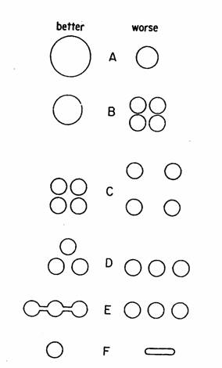

Figure 1........ Size, spacing, orientation and shape of habitat fragments relative to probability of species survival. After Faaborg et al. (1995) after Diamond (1975).

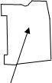Figure 2........ Proposed development area, Belmont Uplands site. Approximate boundary from Epsilon Associates, Inc. (14 Oct. 2003), Conceptual Conservation Restriction Plan. Base Map: 2001 Massachusetts GIS Orthophotos.
the north by Rte. 2 and its access ramp, office buildings and parking lots; on the east, by the West Roadway; on the south by the railroad track; and on the west by houses and Little Pond. Little River and Acorn Park Road are considered as relatively minor habitat discontinuities embedded in the open-space matrix; although clearly a small vertebrate or ground-dwelling invertebrate might treat these linear features as barriers. East of Acorn Park Road, the open space includes less forest, but the dominant effect is one of contiguous, relatively undisturbed vegetation.
As an example of the disturbance effect the proposed development would have on this open-space patch, Figure 3 illustrates its core area at a sample setback of 100 meters (328 feet) from the edge of the patch, with and without the development. Aside from causing a disproportionately heavy loss of mature upland forest, the location of the development results in a halving of the core area.
The location of the proposed development is also prejudicial to the viability of the two reported vernal pools. Figure 4 demonstrates management guidelines promulgated as the result of recent vernal pool research (Calhoun and Klemens 2002). It appears that the 100-foot buffer setback zone prescribed decades ago by the Wetlands Protection Act should be regarded as only the most conservative estimate of necessary protective space. Figure 5 centers two circles around the location of both reported vernal pools, the smaller circle set at the 100-foot mark, the larger set at the outer limit (750 feet) prescribed by Calhoun and Klemens (ibid.) to encompass their recommended management area. The degree to which both outer arcs overlap the proposed development site indicates the possibility of a potentially significant loss of upland habitat for several vertebrate species with a near-total dependency on vernal pools as reproductive sites and the need for extensive upland forest close by.
In actuality, animals dispersing from the vernal pools are unlikely to exhibit radial symmetry in their distribution. Any so-called obligate and facultative amphibians and reptiles using the vernal pool by Little Pond are confined by the pond on the west, the Little River on the south and the Rte. 2 access road on the north. The result may be a disproportionate reliance on the Belmont Uplands forest on the east. Similarly, animals from the other vernal pool would avoid Rte. 2 and its access ramps on the north, and many would find the marsh east and south unsuitable. They would have to cross Acorn Park Road to the west, but within relatively easy reach on the other side is upland forest similar to that surrounding their pool. Most of this highly suitable non-breeding habitat would disappear under the proposed housing development.

3.0 Summary
Over the past decade, the Alewife Reservation has become the subject of intense activity by individuals and organizations with an interest in its preservation as open space. Its biota, diverse for such an urban setting, have been well studied and can benefit greatly in future from habitat improvements proposed as part of several major restoration initiatives. The upland, riparian and wetland vegetation provide important free services in the regulation of stormwater runoff and improvement of water quality. This combination of biotic and physico-chemical functions can only maintain current levels of performance with full protection of the open-space buffer that still adjoins the Reservation in places. The current proposal to develop the Belmont Uplands forest part of this buffer would have its most adverse impacts on certain animal species, particularly those that are area-sensitive, and vernal-pool herpetofauna.
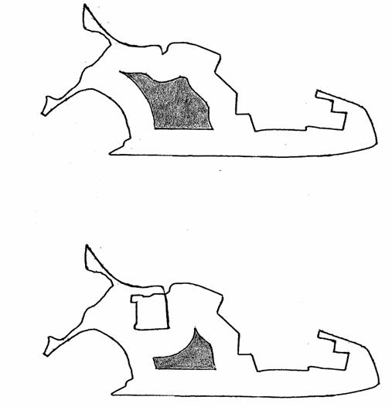

Figure 3........ Core area (shaded) for interior-habitat species at Alewife Reservation without Belmont Uplands development (top) and with development (bottom). Setback from unvegetated edge ~ 100 m..
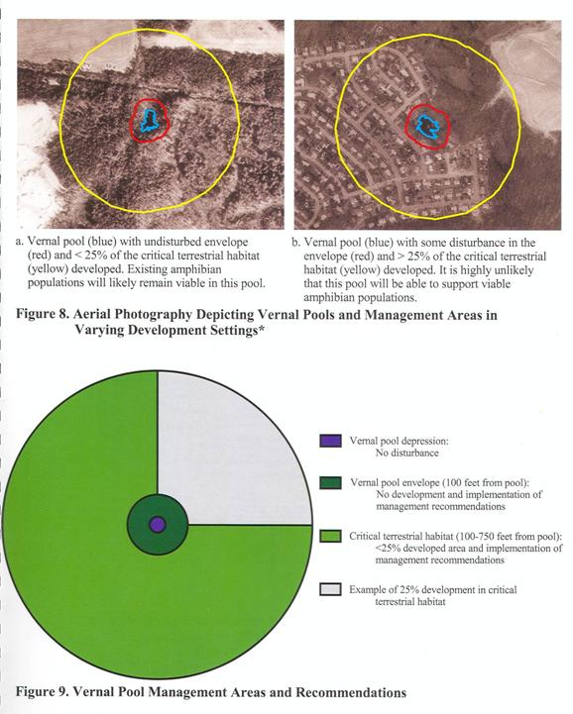
Figure 4........ Recommended terrestrial management area around a vernal pool. Illustration from Calhoun and Klemens (2002).
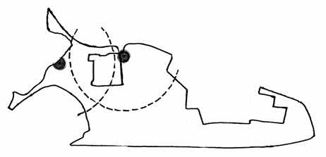
Figure 5........ Relationship to the proposed Belmont Uplands development of two reported vernal pools and their respective 750-foot-diameter terrestrial management areas. Darkened circles indicate approximate area of State jurisdictional protective buffer zone to be observed around vernal pools.

The Alewife Reservation is a public place, a refuge of common resort in the democratic tradition of Frederic Law Olmsted and Charles Eliot, albeit tending to the wild side under current dispensation. Its habitat value for species other than our own is manifestly high, in the absence of alternative suitable habitats nearby. To the extent that the Alewife Reservation habitat serves all us animals well, it deserves management to enhance our common stake in it. That means concern for all the remaining open space around it as well: wetland or upland, meadow, marsh, shrubland or forest. All these parts cohere in ways we must try to understand or at least acknowledge. And we too cohere. The Reservation and environs represent our own vestigial and somewhat ruinate natural heritage. We must not part with any of it lightly.

4.0 References Cited and Reviewed (incomplete as of 7 Feb. 2006)
AP Cambridge Partners II, LLC (2005-December 6) Comprehensive Permit Application, Town of Belmont, Zoning Board of Appeals.
Belmont Conservation Commission (2006-January 18). Letter to Friends of Alewife Reservation from Miriam W. Weil.
Cambridge Discovery Park (undated). Miscellaneous aerial photographs.
City of Cambridge (2002-July 30) Comments on Environmental Notification Form, Frontage Road Office Center, Belmont, EOEA No. 12376R, in letter to Bob Durand (EOEA) from R. W. Healy.
EOEA (2002) Certificate of the Secretary of Environmental Affairs on the Environmental Notification Form. Executive Office of Environmental Affairs, Boston, Massachusetts.
Epsilon Associates, Inc. (2001-September 5) Open space management plan, Belmont Uplands site. Maynard, Massachusetts.
Epsilon Associates, Inc. (2003-August 15) Belmont Office/R & D Building Final Environmental Impact Report, EOEA #12376R. Maynard, Massachusetts.
Epsilon Associates, Inc. ( ? ) Response to comments on Final Environmental Impact Report.
Friends of Alewife Reservation (2004) Biodiversity study of Alewife Reservation Area: species, habitat,and ecosystems. Friends of Alewife Reservation, Cambridge, Massachusetts.
Friends of Alewife Reservation (2006) Website publications and information links.
Kaiser, S. H. (2005-March) Map book of wetlands and floodplain areas at Little River and Alewife Brook in Arlington, Belmont and Cambridge.
Katuska, C. J. (2003) Forest characterization report: Little Pond/Little River, Belmont/Cambridge, Massachusetts.
Katuska, C. J. (2003-November 25) Presentation to Belmont Planning Board on the functions and values of the Belmont Uplands project site.
Katuska, C. J. (2004-February 2) Project impact calculations: Belmont Uplands project (Belmont Office/R & D Building), Acorn Park Drive, Belmont/Cambridge. Memo to Friends of Alewife Reservation and Belmont Citizens’ Forum.
Massachusetts Historical Commission (2002-July 19) Letter to Bob Durand, Secretary, Executive Office of Environmental Affairs, from Eric S. Johnson.
MDC (1999-December) Blair Pond Master Plan, Cambridge and Belmont, Massachusetts. Metropolitan District Commission, Boston, Massachusetts.
MDC (2003-June) Alewife Reservation and Alewife Brook Master Plan. Metropolitan District Commission, Boston, Massachusetts.
NHESP (2001) BioMap: Guiding land conservation for biodiversity in Massachusetts. Natural Heritage and Endangered Species Program, Westborough, Massachusetts.
NHESP (2002-November 7) Letter to Ellen Mass from Patricia Swain. Massachusetts Division of Fish and Wildlife, Westborough, Massachusetts.
Rizzo Associates ( ? ) Environmental Impact Report. Framingham, Massachusetts.
Sanders, S. (1994) An Alewife area ecology guide. Mystic River Watershed Association, Arlington, Massachusetts.
Stark, D. J. (2003-June 3) Memorandum reporting certifiable vernal-pool activity (20 March 2003) abutting Belmont Uplands project property, with supporting documentation. Environmental Technology Program, Minuteman Regional High School, Lexington, Massachusetts.

