Dave Brown Wildlife Walk
Facing the challenges of the future
Date: Saturday, December 20, 2014 Time: 3:00pm - 5:00pm

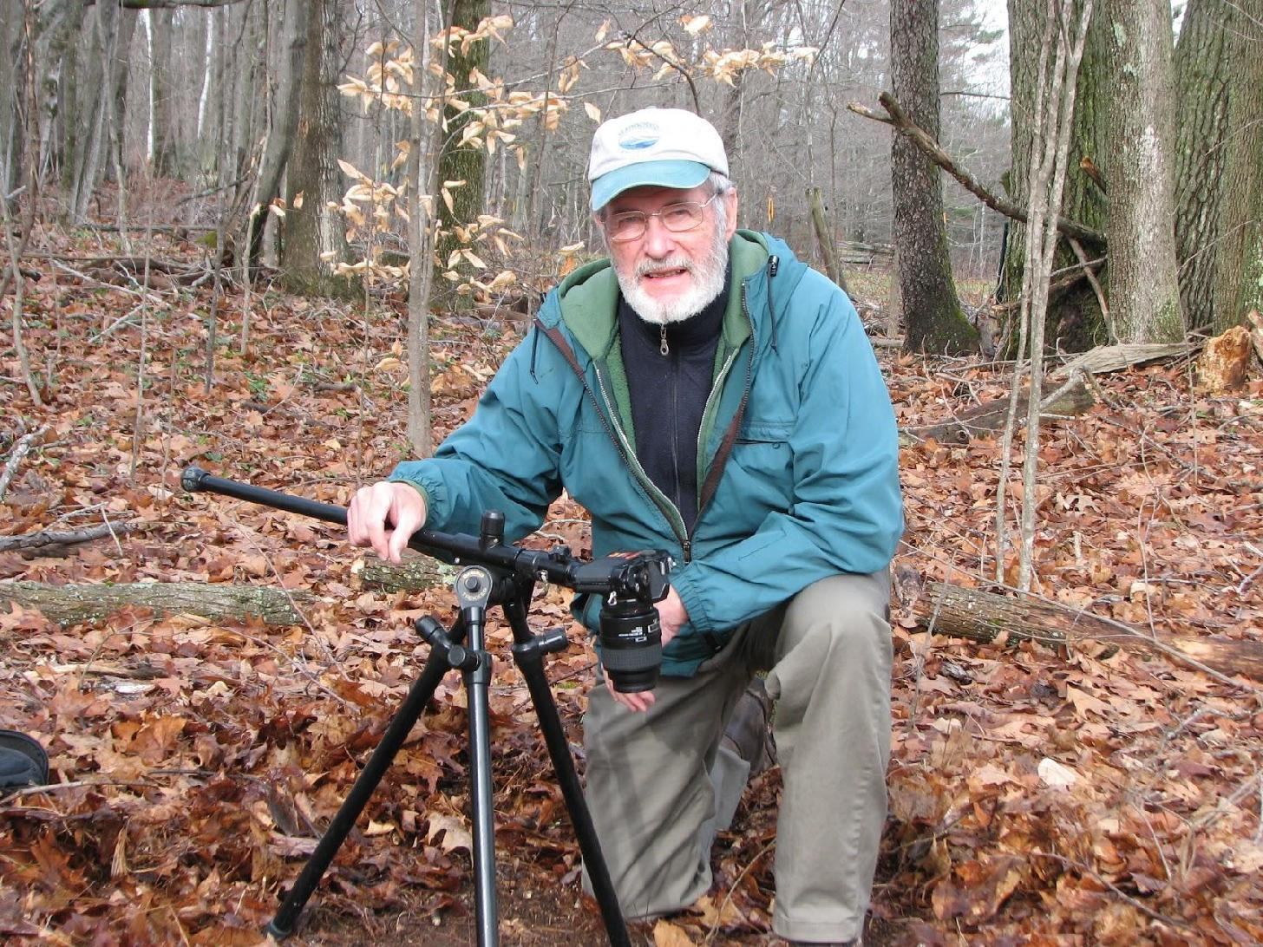

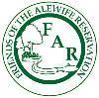

Dave Brown will help us face the habitat loss we will see and help us to view the area fully so that we can help to protect what remains, and understand what is before us. Some tracking and wildlife information will be imparted, and questions answered by Dave about the Reservation and its important value as an urban wild and wildlife refuge.

Contact: 617 415-1884 Location: Acorn Park Drive, Cambridge, MA 02140
Direction: (map and directions to events at Alewife Reservation )
Take a Virtual Tour first:
http://friendsofalewifereservation.org/2013_Archive/2013-01-13-virtual-tour.htm

