Silver Maple Solstice Celebration
Alewife Reservation- Call to Action

Families and children welcome

Join with forest life and celebrate our nature kinship

Become a silver maple branch and grow the forest forever

Spiritual leader, Maya Apfelbaum leads the 8th ritual
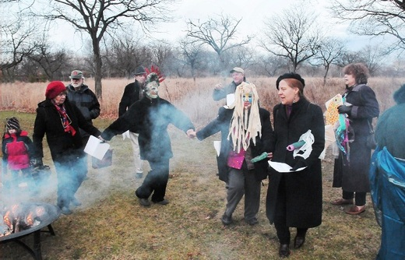
Find out more here
December 14th at 3pm- Alewife Reservation Parking Lot, Acorn Park Drive Saturday
(After the 1:00pm Wildlife Walk with Dave Brown, Cambridge, Ma)

Dance around the Fire and Celebrate
Return of Light to our Mystic/Alewife communities
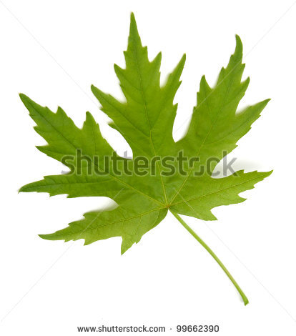
Call 617-415-1884 for more information. Maya: 978-339-3101
Sponsored by Friends of Alewife Reservation, Green Cambridge. www.friendsofalewifereservation.org,
Mystic River Watershed Association: http://mysticriver.org/myrwa-blog/

Bring your nature spirits and instruments- Volunteers needed to help Maya

