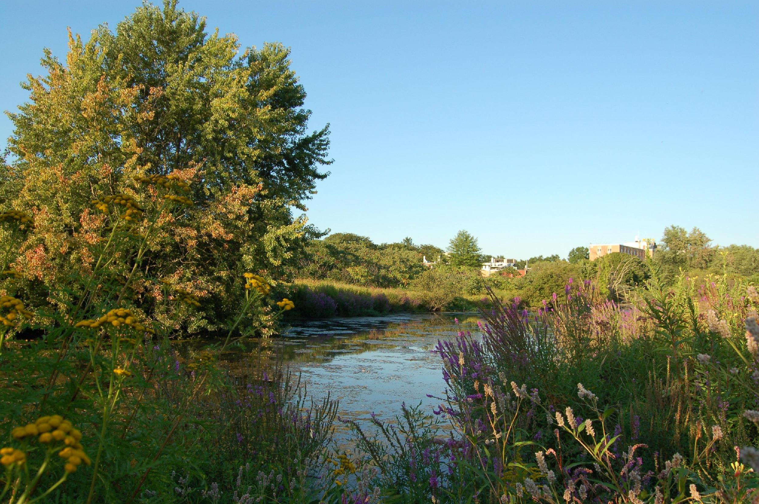
Alewife Reservation
Fall Clean up

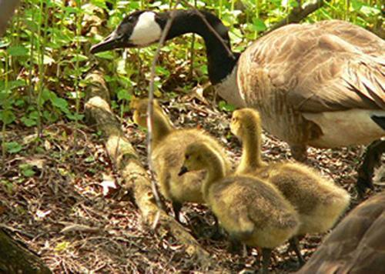
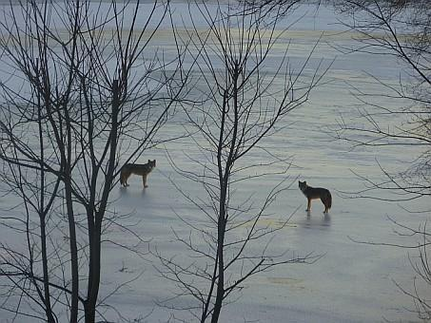
The Alewife Reservation is an urban wild located next to the Alewife T-stop. Home to 100’s of species, including hawks, coyotes beavers, snapping turtles, wild turkeys and muskrats, the reservation is a unique natural resource for the community. Join the Friend’s of the Alewife Reservation and the students and faculty from the Department of Natural Sciences and Mathematics to help clean up trash and debris from the Reservation and prepare it for winter!

Meet at the Alewife Reservation at
11:00 am on Saturday Dec. 7th!
(rain date the 8th)

Dress warm and bring a bottle of water. All are welcome!
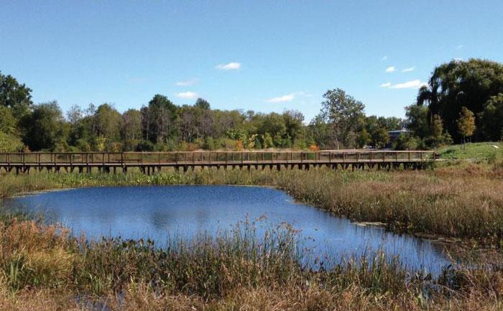
Directions: From the Alewife T-stop passenger pick-up area, cross the street and walk slightly north (right). You’ll see a small bridge; we will meet by the garden next to the bridge.

