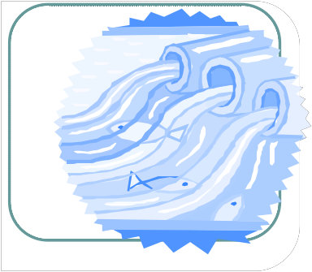
Water

Trouble

A Public Forum on Storms, Floods, and Pollution
THURSDAY, SEPTEMBER 13, 2012 7:00-9:00 PM
WINN BROOK SCHOOL CAFETERIA
97 Waterhouse Road, Belmont

- Hear experts discuss local and regional storm water management issues
- Find your home on FEMA flood pattern maps
- Understand the storm water requirements that Alewife developments must meet
- Learn how you can influence government decisions about flood prevention & pollution

Panelists
Kathleen Baskin Director of Water Policy, Mass.
Glenn Clancy Director, Community Development, Belmont
Patrick Herron Mystic Monitoring Network Director, MyRWA
Ralph Jones Belmont Selectman
Richard Vogel Director Tufts University: "Water: Systems, Science, and Society”
Moderator
Fred Paulsen Belmont Town Meeting Member

Find out how you can improve water quality and reduce flooding in Belmont, Arlington, and Cambridge.
Corporate Silver Level Sponsors Nonprofit Cosponsors
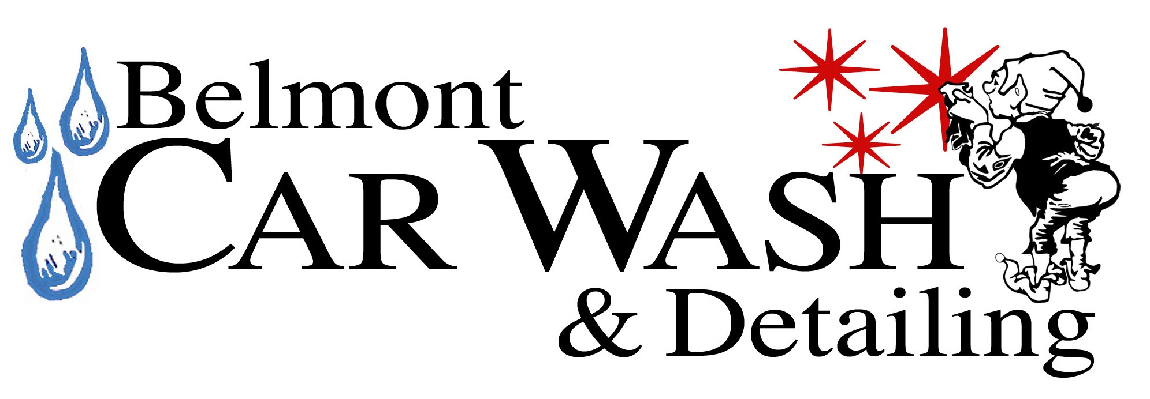
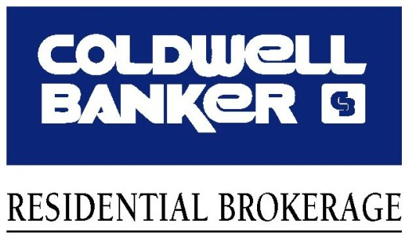
Sustainable Belmont
Mystic River Watershed Association
Friends of Alewife Reservation
Coalition to Preserve the Belmont Uplands

Corporate Gold Level Sponsor
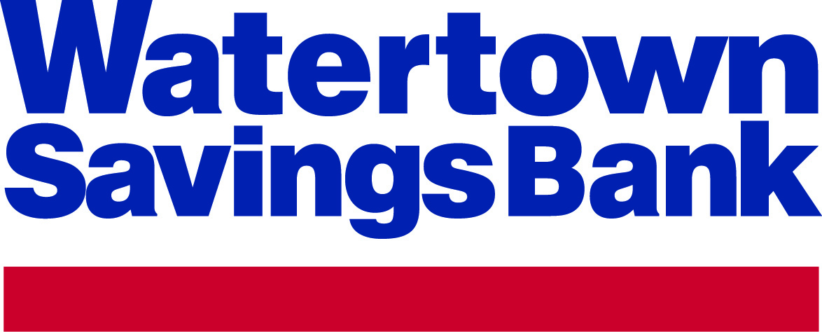

Presented by the Belmont Citizens Forum
belmontcitizensforum.org bcfprogramdirector@gmail.com

