

DCR Coastal Awareness Environmental Education Program
By appointment January and February

A DCR educator is available to visit schools, libraries, hospitals and other meeting places to present the following programs:

Spectacular Seashell Animals (1hr.)
Suitable for children in grades 4 through High School. Using hands-on activities, children will learn about animals that live in coastal and marine habitats.

Sea Turtle Surprises (1 hr.)
Suitable for children in grades K through 5.
During this lively presentation, children will learn about the turtles that visit the coast of Massachusetts and some of the problems that they face.

To arrange for a visit, call 781-485-2803 ext. 105, or email Matthew.Nash@state.ma.us, or

Nature’s Mysteries!
Thursdays Jan. 26th & Feb. 9th
3:30pm-4:30pm

Saturdays Jan. 28th & Feb. 18th
10am-11am… and… 1pm-2pm

Suitable for children ages 5-11.
Join a DCR educator and naturalist for a lively learning adventure on the lives of animals. Suitable for children ages 5 to 11.
Pre-registration is required. For info and registration call 781-485-2803 ext. 105, or email Matthew.Nash@state.ma.us
(This program can also be arranged for groups by appointment.)
Thursdays Meet at: One Eliot Circle, Revere
Saturdays Meet at: Christopher P. Dunne Visitor Center, 177 Forest St., Saugus
North Region Winter
2011 – 2012

Breakheart-Fells Weekly Hikes

All hikes begin at 1pm.
The last hike of every month will explore the Middlesex Fells Reservation and meet at Botume House Visitor Center at 4 Woodland Rd., Stoneham. All other hikes will meet at Breakheart’s Christopher P. Dunne Visitor Center, 177 Forest St (off Lynn Fells Pkwy), Saugus.

For info, call 781-233-0834.
Hikes cover several miles and may be too strenuous for children under 10. No dogs, please.

March

Sun, Mar. 7: B♥ Tr., Fox Run Link, B♥ Hill, Saugus R.
Sun, Mar. 14: Ridge, Lakes, Fern-Spruce, Ridge Link
POTLUCK LUNCH TO FOLLOW!
Sat, Mar 20: Frog Pond, Saug. R., Lakes, Fox Run
Sun, Mar. 28: Fells Hike, 3 hours, considered difficult

April

Sat, Apr.3: B♥ Hill & back, Marsh, Rgr Tr, Frog Pond
Sun, Apr. 11: Lakes, Ridge Link, Crow Hill, Saugus River
POTLUCK LUNCH TO FOLLOW!
Sat, Apr. 17 : Ash Hill, Silver, Fox, Saugus. R, B♥ Hill
Sun, Apr. 25: Middlesex Fells Hike, 3 hours, considered difficult

May

Sat, May 01: B♥ Hill, Lakes, Eagle Rock, Fox Run
Sun, May09: Frog Pond, Ranger, Marsh, Saug. R.-Fox
Sat May 15: Fox Run, Eagle Rock/Lakes, B♥ Hill
POTLUCK LUNCH TO FOLLOW!
Sun, May 23: Middlesex Fells Hike, 3 hours, considered difficult

Adaptive Skating-Games on Ice
Tuesday January 10th, February 14th, and
March 20th, 11:30am-1:30pm
Everyone is welcome to try out an ice sled at no cost. Conventional ice skates are available for rent, or bring your wheelchair on the ice. Come with your waiver filled out before you arrive to get into the activity sooner. Waivers can be found at www.mass.gov/dcr/universal_access/docs/waiver.pdf For info or to check the program status in the event of poor weather, call 617-626-1294
Meet at: Cronin Rink, 850 Revere Beach Parkway, Revere.

Park Field Trips
By Appointment December through February
Educators and youth leaders are welcomed to book field trips to beautiful DCR North Region
(Metro North) forest, marsh and coastal locales.
For more info and registration call 781-231-1203 or email Lynn.Hildenbrand@state.ma.us

For additional programs and info, go to:

www.friendsofalewifereservation.org: Frnds. of Alewife
www.friendsofbelleislemarsh.org: Friends of Belle Isle
www.saugus.org/FOBR: Friends of Breakheart Reserv.
www.charlesriverconservancy.org: Ch. R. Conservancy
www.esplanadeassociation.org: The Esplanade Assoc.
www.fells.org: Friends of the Middlesex Fells Reserv.
www.gbnemba.org: Greater Bos. N.E. Mtn. Bike Assoc.
www.lynn-nahantbeach.org: Frnds of Lynn/Nahant Bch.
www.fomr.org: Friends of the Mystic River
www.mysticriver.org: Mystic River Watershed Assoc.
www.reverebeachpartnership.com: Rev. Bch. Prtnrship.
www.saugusriver.org: Saugus River Watershed Assoc.

Breakheart-Fells Weekly Hikes
All hikes begin at 11am,
except the Jan 1st hike begins at 12pm

The last hike of every month will explore the Middlesex Fells Reservation for 3 hours and meet at the Botume House Visitor Center located at 4 Woodland Rd, Stoneham. All other hikes meet at the Christopher P. Dunne Visitor Center, Breakheart Reservation, 177 Forest St (off Lynn Fells Pkwy), Saugus and last for 2 hours.

For info, call 781-233-0834.
Hikes cover several miles and may be too strenuous for children under 10. No dogs, please.

December

Sat, Dec 3: Fox Run, Saugus River, Nihan, Mill Trail
Sun, Dec 11: Ridge, Ash, Eagle Rock, Lakes, B♥ Hill

Sat, Dec 17: Fells Hike, 3 hours in duration

January

Sun, Jan 1: 1st Day Hike (Begins 12pm see description, reverse side)
Sat, Jan 7: Saugus River Trail, Castle Rock/Ridge
Sun, Jan 15: Ash Hill, Lakes, Fox, Saug. R., B♥ Hill

Sat, Jan 21: B♥ Hill, Lakes, Eagle, Power Lines, Fox

Sun, Jan 29: Fells Hike, 3 hours in duration

February

Sat, Feb 4: Ridge, Lakes, Fern Trail, Crow Hill, Ridge
Sun, Feb 12: B♥ Hill, Fox, Eagle, Castle, Ridge

Sat, Feb 18: B♥ Hill, Lakes, Ridge Link, Saugus River

Sun, Feb 26: Fells Hike, 3 hours in duration

Great Destinations Slide Show
December thru February, by appointment

This travelling slide show of the prettiest places in the Commonwealth can be arranged at your Senior Center or Library. For more info and registration call 781-231-1203 or email Lynn.Hildenbrand@state.ma.us

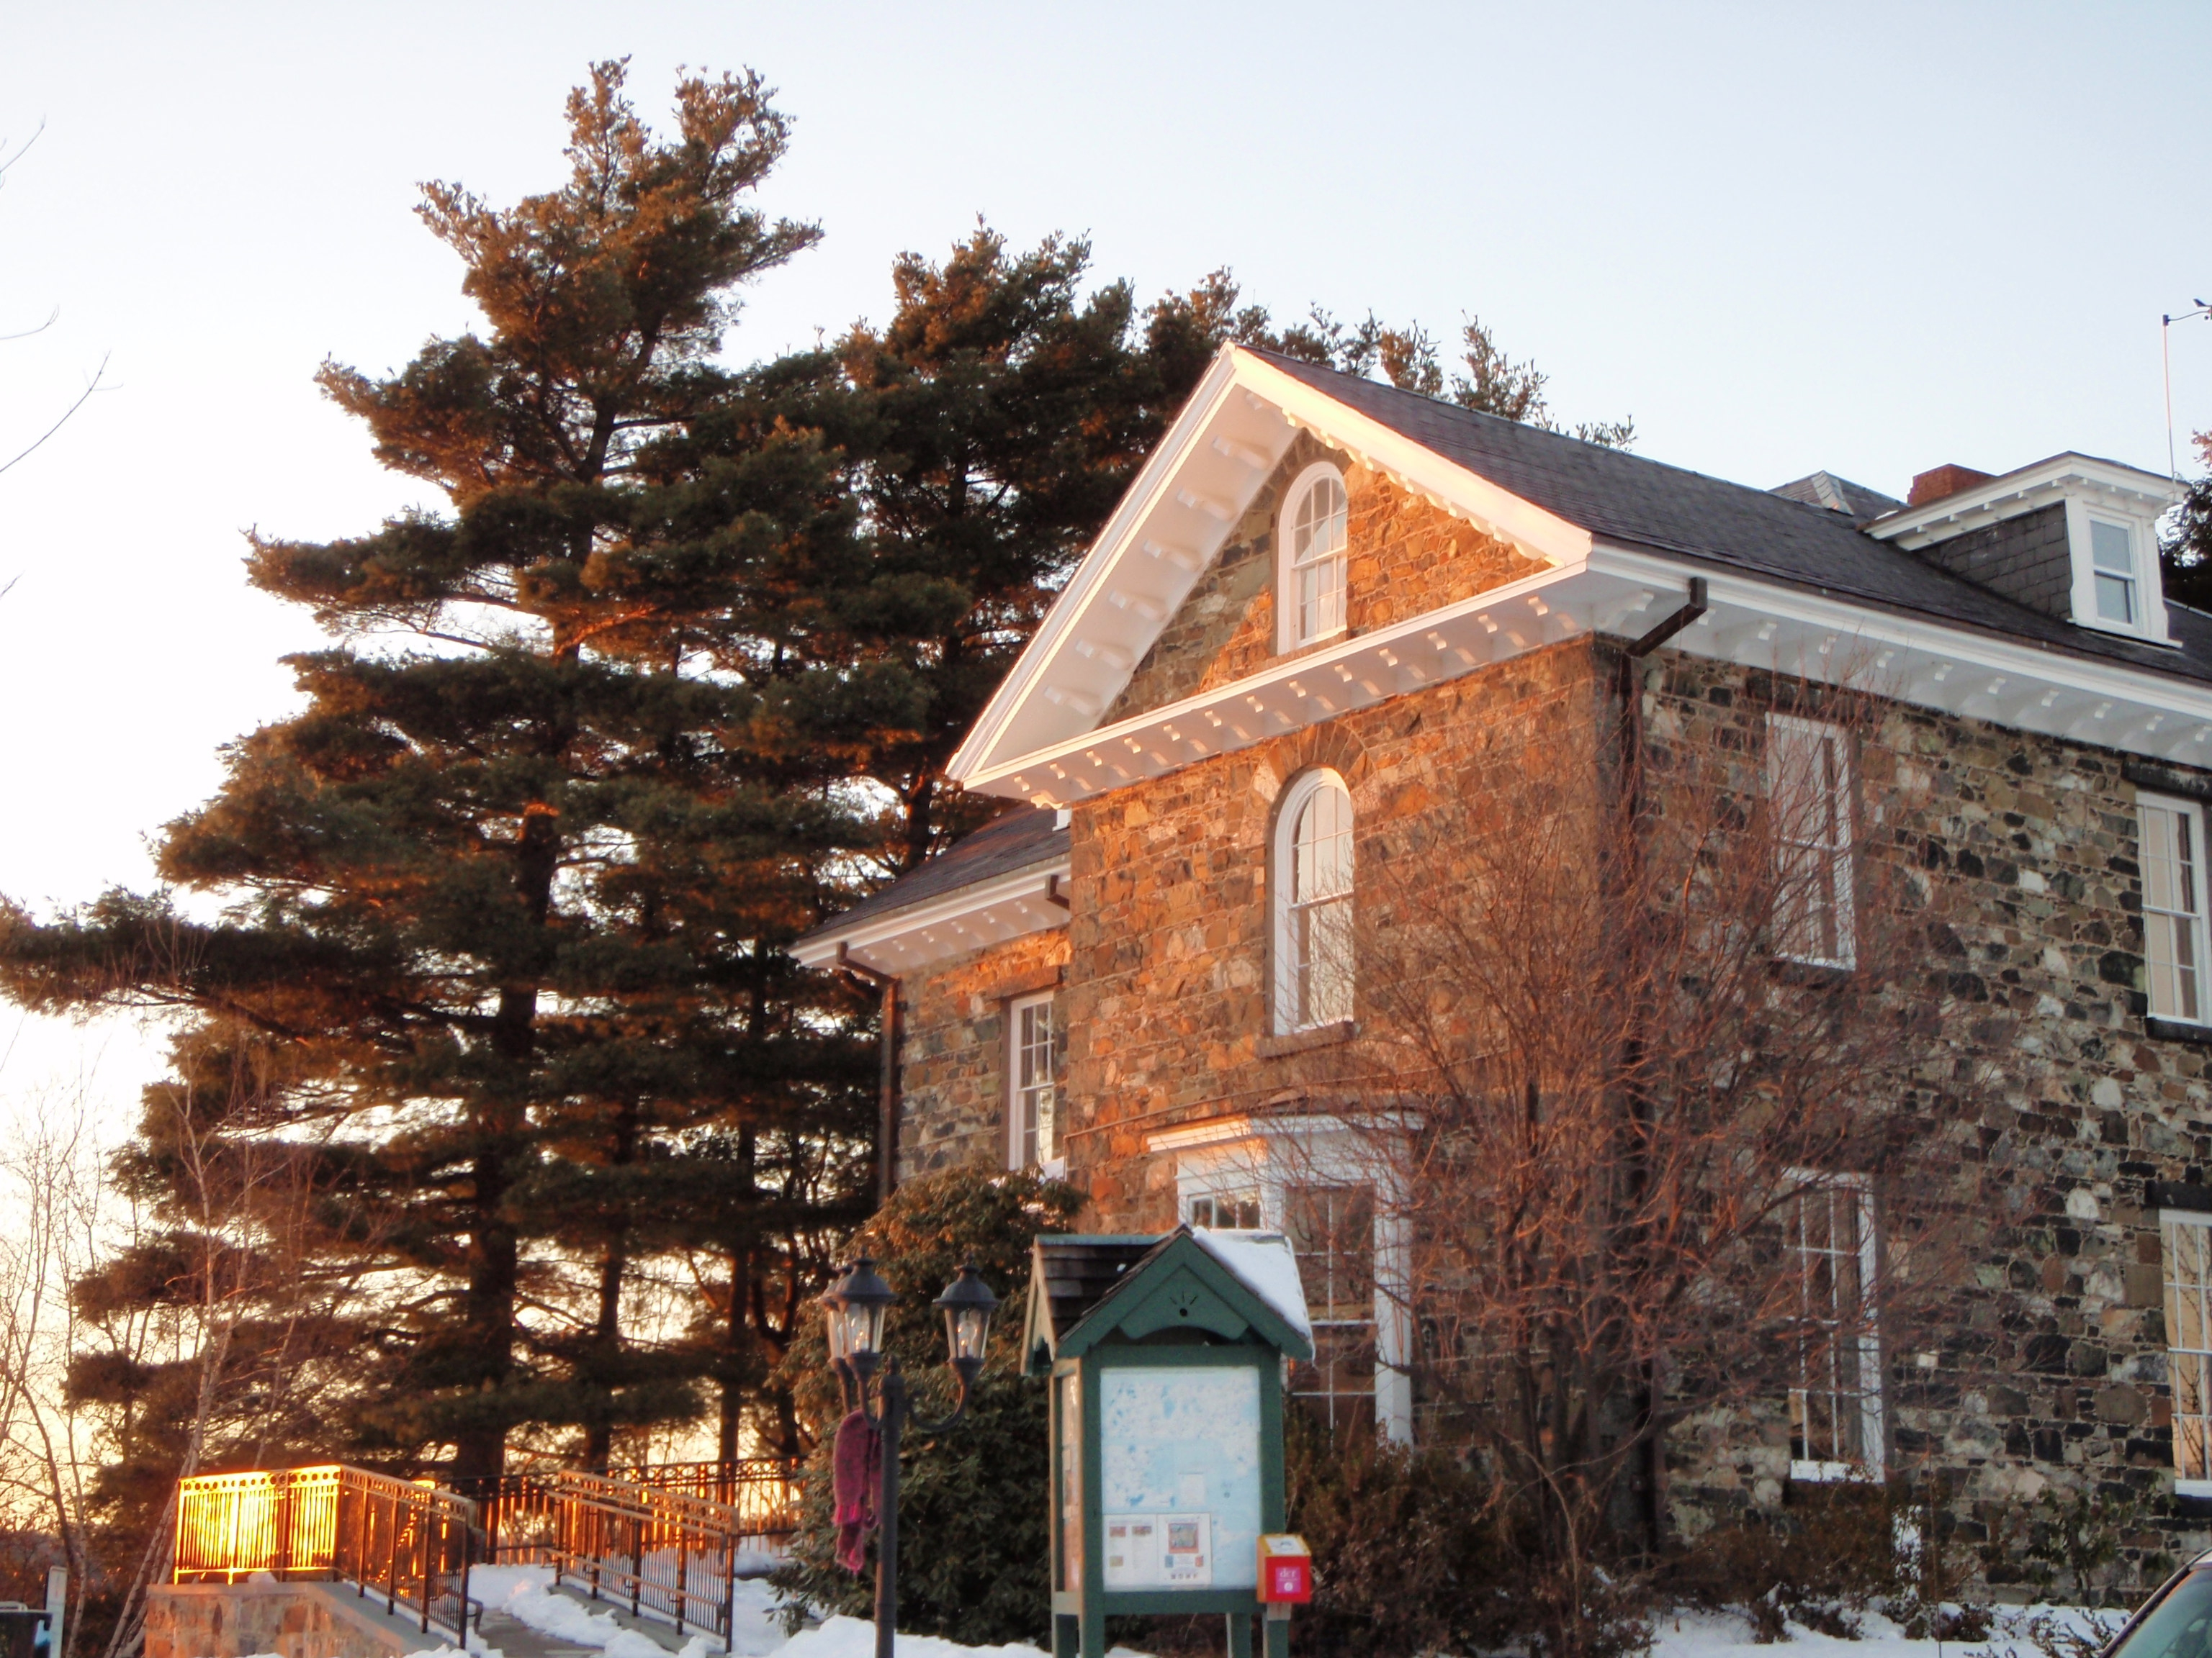



DCR North Region Headquarters
4 Woodland Road, Stoneham, MA 02180
Tel: (617) 727-1199 Fax: (617) 727-8228
www.mass.gov/dcr

Alewife Brook Reservation
Beaver Brook Reservation
Belle Isle Marsh
Breakheart Reservation
Charles River Reservation
Constitution Beach
Lynn Heritage State Park
Lynn / Nahant Beach
Mary O’Malley Park
Middlesex Fells Reservation
Mystic River Reservation
Revere Beach
Rumney Marsh Reservation
Winthrop Beach

January
Annual Breakheart 1st Day Hike
Sunday, January 1st, 12pm
A tradition continues with our Annual 1st Day Hike. What better way to start the year than with a brisk hike at Breakheart Reservation? After the hike, free clam chowder and hot drinks will be served, while they last. DCR first day hike Passport stamps will be available. Co-sponsored by the Friends of Breakheart. Meet at: Christopher P. Dunne Visitor Center, 177 Forest St., Saugus. Please arrive a few minutes before the start time. Visit www.mass.gov/dcr/events.htm for more info. In the case of stormy weather or icy trail conditions, please call 617-626-1450 for a listing of first day hike cancellations.

Charles River Dam Tour
Saturday, January 14th, 2pm-3pm
Join a DCR park Ranger for a tour of the facility that keeps the Charles River from flooding the neighborhoods of Cambridge and Boston’s Back Bay. Meet at: Paul Revere Park, at the flagpoles, just below the Charlestown Bridge and City Square.

Express Spanish for English Speakers
(Espanol Expreso)
Saturday, January 21st, 11am-1pm
Join us to quickly learn to speak some Spanish. For persons with no prior Spanish language experience. Pre-registration is required. For more info, call 781-485-2803, ext. 105, or email Matthew.Nash@state.ma.us

Trees in Winter
Saturday, January 28th, 1:30pm-2:30pm
This is a great time of year to appreciate and discuss the beauty of our lovely park trees. Meet at: the plaza in front of the Museum of Science.

December

Breakheart Movie Nights
Fridays December 2nd, January 6th and
February 3rd , 7pm-9pm
Come to Breakheart for hot cocoa, a roaring fire, and a family movie. For info, call 781-233-0834.
Co-sponsored by the Friends of Breakheart Reservation. Meet at: Christopher P. Dunne Visitor Center, 177 Forest St., Saugus.

Charles River Dam Tour
Saturday, December 10th, 2pm-3pm
Join a DCR park Ranger for a tour of the facility that keeps the Charles River from flooding the neighborhoods of Cambridge and Boston’s Back Bay. Meet at: Paul Revere Park, at the flagpoles, just below the Charlestown Bridge and City Square.

Calling All Junior Rangers - December Break
Wednesday thru Saturday, Dec. 28th thru 31st , ,
10am-12pm
Become a Junior Ranger during school
vacation! Geared toward ages 8-12; friends and siblings welcome. Attention Scouts: You may earn Merit Badges too! Complete 8 activities and earn your Junior Ranger patch. Come every day, or just join us 1 time. Pre-registration required. Call Lynn Hildenbrand at 781-231-1203. Meet at: Botume House Visitor Center, 4 Woodland Rd., Stoneham.

Out with the Old Year Walk
Saturday, December 31st, 1:30pm-3:30pm
This one’s purely for exercise. Be ready for a spirited walk around the Charles River basin. Meet at: the plaza in front of the Museum of Science.

Wildlife Tracking at Breakheart
Sunday, January 29th, 1:30pm-3:30pm
Join expert tracker David Brown in search of wildlife tracks and signs. If there is snow we may be fortunate enough to discover the trails of coyote, and other animals normally associated with distant wilderness. Two miles or less will be covered at a slow pace. Wear warm clothes and sturdy footwear. For info. call 781-233-0834. Meet at: Christopher P. Dunne Visitor Center, 177 Forest St., Saugus

February

Maple Sugarin’ Pre-registration
Mon. thru Fri., starting Wed., Feb. 1st, 10am-4pm
School and non-profit groups can call to sign up for Breakheart’s Annual Maple Sugarin’ event in mid-March. Pre-registration is required: Call Rita at 617-727-1199, ext. 406.

Snow Moon Hike
Tuesday, February 7th, 5 pm-6:30pm
Come enjoy the full snow moon on a hike to Bear Hill Tower. Arrive about 15 minutes early and leave your flashlights at home. Wear warm clothes and sturdy footwear. Meet at: Sheepfold upper parking lot of the Middlesex Fells Reservation.

Winter Tracking at Belle Isle Marsh
Saturday, February 11th, 9am-10:30am
Search Belle Isle Marsh for tracks and signs of animals. Wear warm clothes and sturdy footwear. Meet at: Belle Isle’s main parking lot, Bennington St., East Boston.

Walk the Lost Half-mile
Saturday, February 11th, 1:30pm-3:00pm
Join us for this stroll along the exciting new waterfront parks that we are creating, along the last stretch of the Charles River before it meets the harbor. We’ll see what’s been built and discuss future plans. Meet at: the plaza in front of the Museum of Science.

February School Vacation Week
Join a DCR educator and naturalist for a lively learning adventure on the lives of animals. Suitable for children ages 5 to 11(These programs can also be arranged for groups by appointment.)

Bats in your Backyard
Wednesday February 22nd
10am to 11am repeats 1pm to 2pm

Sea Turtle Surprises
Thursday, February 23rd
10am to 11am repeats 1pm to 2pm

Sweet Honeybees
Friday, February 24th
10am to 11am repeats 1pm to 2pm

Meet at: Eliot House, One Eliot Circle, Revere
Pre-registration is required. For info and registration, call 781-485-2803 ext. 105, or email Matthew.Nash@state.ma.us

Blanket the Globe
Saturday, February 25th, 9am-noon & 1:30pm-4pm
Drop in anytime for about an hour or less. Children artistically express their love and\or concerns for nature on a blanket that is displayed at public events.
All materials will be provided. For more info visit http://www.blankettheglobe.org, call 781-485-2803 ext. 105 or email Matthew.Nash@state.ma.us
Meet at: Eliot House, One Eliot Circle, Revere
(This program can also be arranged for groups)
Winter Campfire Festival 
Saturday, February 25th, 12pm-2pm
Come enjoy hot chocolate and good company by a warm campfire. Wear warm clothes. Meet at: Camp Nihan, 131 Walnut St., Saugus.

Charles River Dam Tour
Saturday, February 25th, 2pm-3pm
Join a DCR park Ranger for a tour of the facility that keeps the Charles River from flooding the neighborhoods of Cambridge and Boston’s Back Bay. Meet at: Paul Revere Park, at the flagpoles, just below the Charlestown Bridge and City Square.

Programs & Events
DCR North Region -
grams







